**“FINALISED EVENTS - IT”**

**Event: Android Star**

**Event coordinators:** Gyansree Hirawath(20341A1233), Y. Sai Polaraju(20341A12C7)  
**Team size**: 3 – 4 per team  
**Expected registrations**:30 teams  
**Amount from registrations**:6000/-  
**Others costs**: items, price-NA  
**Prize money**:1st-6000/-  
 2nd-4000/-  
 3rd-NA   
**Budget expected**:1000/- required  
**Registration fee:** 300/-  
  
**Description:** Android Star is similar to Hackathon. Here in this, we will give a problem statement to the teams who have registered. They have to come up with a solution and have to build an android app. And after the completion of the time given to them for building their app their team leader have to explain their approach and also have to explain how efficient will their solution will work. They will be assessed by the judges and then the team who scores the highest will be declared as winners.

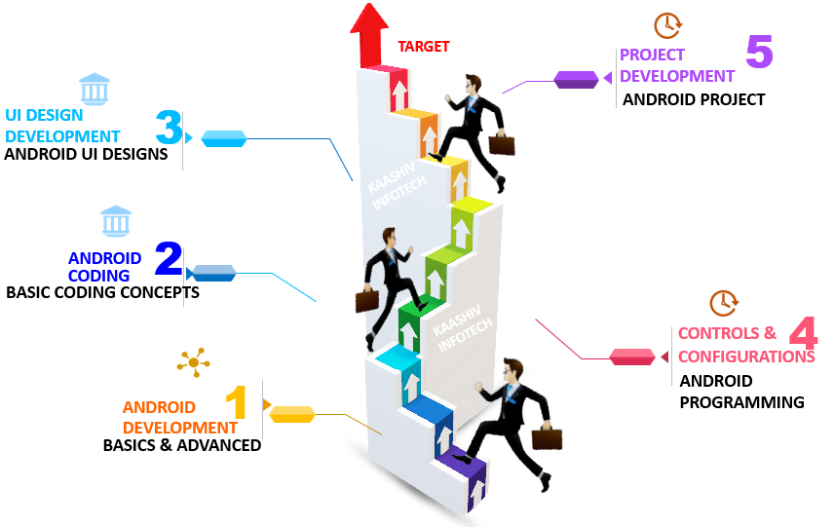

**Event**: **Spawn The Machine**

**Event coordinators:** V. Gowtham Sai(20341A12B8), P. Gangadhar(21345A1206)  
**Team size:** 1 – 2 per team   
**Expected registrations**:80 teams  
**Amount from registrations**:2000/-  
**other costs**: items, prize-NA  
**Prize money**:1st-6000/-  
 2nd-3000/-  
 3rd-1000/-  
**Budget expected:**2000/-  
**Registration fee:** 80/- (1) , 150/- (2)  
**Description :**  The candidate must spawn or capture the flag by answering the questions given by HACKTHEBOX. Hack the Box is a website containing machines to be spawned categorized based on topics. Candidate can select any of the machine and continue to answer the questions to reach the practical part. Based on the topic chosen, the candidate has to configure the kali system to obtain a file called root.txt (based on the topic). Candidate have to copy the key specified to capture the flag and that was it. We can have up to 3 rounds, where 2 rounds will be of 45 minutes each and the other one with 60 minutes. In each round, a candidate can spawn machines as much as he/she can within the time limit. The person with more spawns within less time will be qualified for the next round. The last round will be consisting of 2 machines to be spawned specified by the evaluator. 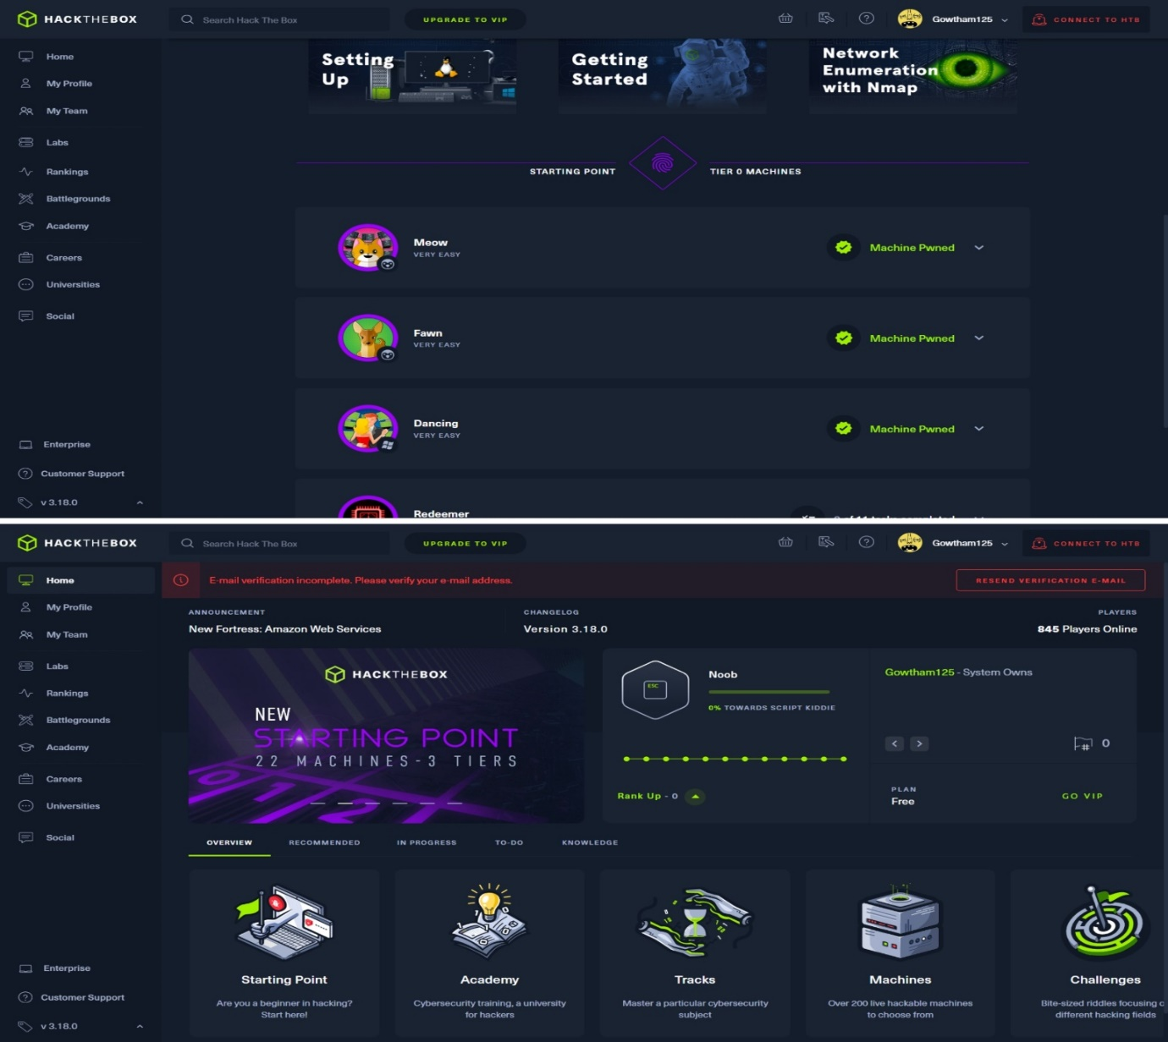

**Event: Mr &Ms Technica**

**Event coordinators :** V. Nirmala Priya(20341A12C2), M. Vinay Kumar(20341A1271)  
**Team size** **:** Individual  
**Expected Registrations**:60(Individuals)  
**Amount From Registrations**:12000/-  
**Others costs**: items -crown and other item  
 price-5000/-  
**Prize money**: 1st-6000/-  
 2nd-3000/-  
 3rd-NA  
**Budget Expected**:2000/- required  
**Registration fee :** 200/-  
**Description :** Mr & Ms Technica is a combination of five segments to find out the skilful people who are capable to do well in all kinds of aspects. This event brings out the skills among the students and help them to improve in all the aspects of this competitive world. Mr & Ms Technica triggers out the hidden talents of students and helps students to take good decisions at any kind of situations.  
 Segments of Mr & Ms Technica: Quiz  
 Code vs Time  
 Group Discussion  
 Astavadhanam  
 HR Round

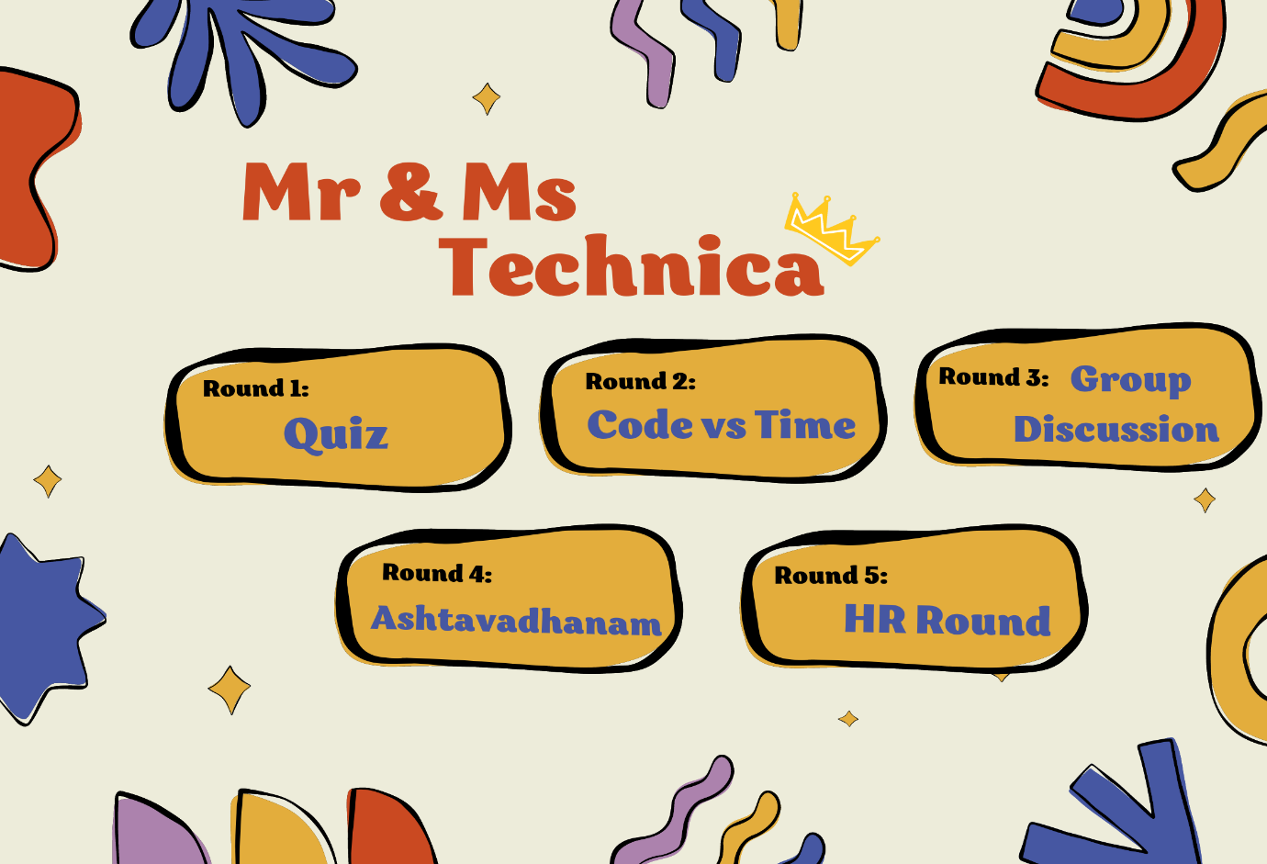

**Event: Code Tunnel**

**Event coordinators:** S. Vandana Sree (20341A12A3), B. Rajitha (20341A1297)  
**Team size:** 2 per Team  
**Expected Registrations**:60 Teams  
**Amount from Registrations**:18000/-  
**Others costs**: items -Tunnel arrangements and Gifts  
 price-43,000/-  
**Budget Expected**:25,000/- required  
**Registration fee:** 300/- per Team

**Description:** The unique concept of an event is that the participants have to clear the first round in order to move to the next round, the main part of the event, the tunnel, a Halloween environment where participants have to solve the given codes in that environment. The tunnel is divided into sections and the difficulty level of code will be increasing for every section and the team that solves all the sections will be the winner.

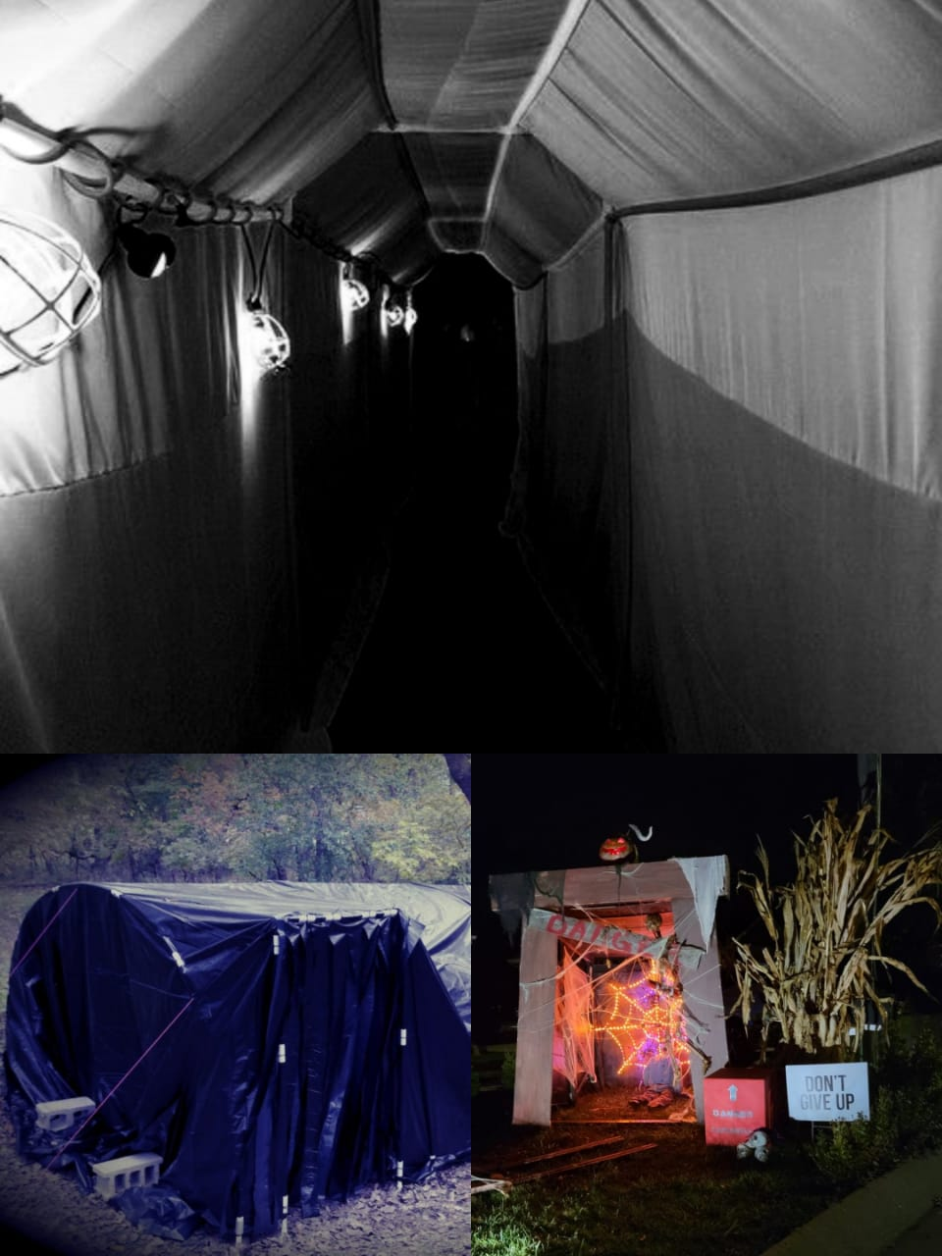

**Event: Model United States**

**Event coordinators: P. SreeVatsav(20341A1287), V.Nirmala Priya(21345A12C2)  
Team size : 3 - 4 per team  
Expected registration:30 teams  
Amount from registrations:9000/-  
Others costs: items-flag posts  
 price-1500/-  
Prize money:1st-5000/-  
 2nd-2500/-  
 3rd-NA  
Budget expected: NA  
Registration fee : 400/- (3) , 500/- (4)  
  
Description :** The Model United Nations is a collection of activities conducted all across the nation and the world with the objectives of advancing knowledge of the UN, teaching participants about global concerns, and promoting peace and the UN's work through collaboration and diplomacy. Students take on the role of a country, group, or individual and collaborate with delegates from other nations to find a solution to problem. MUN teaches participants critical thinking, teamwork, and leadership skills in addition to research, public speaking, debating, and writing abilities.

